**Functional Specification**

**CLICK SENSOR HUB**

**Project Manager: Alfonso de la Morena**

**Dylan Dean, Mohamed Sghari**

**Faculty Advisor: Dr. Stapleton**

**Texas State University**

**Ingram School of Engineering**

**SPONSOR NXP**

**6501 W WILLIAM CANNON DR**

**AUSTIN, TX 78735**

**10/04/2018**



|  |  |  |  |
| --- | --- | --- | --- |
| **Revision History** | | | |
| **Version** | **Date** | **Description** | **Author** |
| 0.1 | 09/19/2018 | Initial read and section assignment | Alfonso |
| 0.11 | 09/20/2018 | Finished Section | Dylan |
| 0.2 | 09/24/2018 | Start work on personal sections | Alfonso |
| 0.22 | 09/25/2018 | Finished Section | Dylan |
| 0.3 | 09/26/2018 | Finished Section | Dylan |
| 0.31 | 09/26/2018 | Start working on terminology used | Mohamed |
| 0.32 | 09/27/2018 | Start working on diagram | Mohamed |
| 0.33 | 09/28/2018 | Finished Section | Dylan |
| 0.4 | 09/28/2018 | Add Diagrams and work on sections | Alfonso |
| 0.41 | 09/30/2018 | Finished Section | Dylan |
| 0.42 | 10/03/2018 | Finished Section | Dylan |
| 0.5 | 10/03/2018 | Interface of FRDM and Clicks | Mohamed |
| 0.6 | 10/04/2018 | Edited document wording and worked on sections 2.1, 2.7 and 2.8 | Alfonso |

Table of Contents

1 Introduction 4

1.1 Summary 4

1.1.1 Milestone #1 4

1.1.2 Milestone #2 6

1.1.3 Milestone #3 6

1.2 Customer Requirements 6

1.3 Existing System 7

1.4 Terminology 8

2 Functional Description 9

2.1 User Attributes and Use Cases 11

2.2 Administration Functions 12

2.3 Error Handling 12

2.4 Safety and Security 13

2.5 Help and User Documentation 14

2.6 Interfaces 14

2.6.1 User 14

2.6.2 Software 14

2.6.3 Hardware 14

2.6.4 Mechanical 17

2.7 Boundary Conditions and Constraints 17

2.8 Performance 19

2.9 Software Platforms 21

2.10 Service, Support, & Maintenance 21

2.11 Expandability or Customization 21

3 Project Alignment Matrix 22

4 References 23

5 Approvals 24

# **Introduction**

Alfonso de la Morena:

The Click Sensor Hub Project will create an PCB interface between NXP’s FRDM-KL46Z microprocessor board and a minimum of 4 simultaneous Clicks from MikroElektronika. The Clicks will be chosen from a pool of 10 that will have software written for them in the Mbed compiler. Once the interface is functional, the data will be collected and sent wirelessly to be displayed on a website that will perform analytics. Thereby, demonstrating a real-world application.

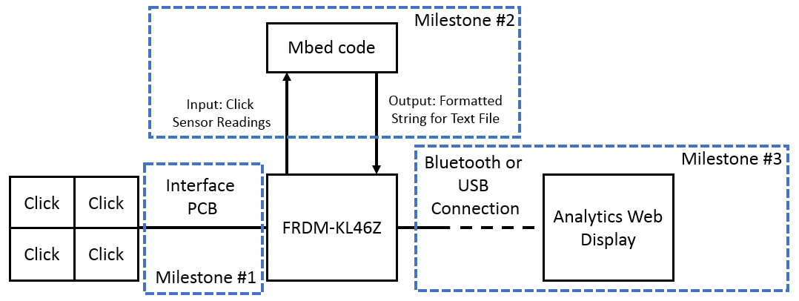

Figure 1: High Level Project Scope Block Diagram

## Summary

Alfonso de la Morena:

The project is split into three main milestones:

### Milestone #1

Milestone #1, the creation of a PCB that can integrate up to 4 simultaneous Clicks with the FRDM-KL46Z, is the more hardware focused aspect of the project. The design for the PCB focuses on adapting 4 mikroBus standard sockets simultaneously to the FRDM-KL46Z. The FRDM-KL46Z pins typically allow for a maximum of 2 SPI, 1 IIC and 1 Analog interface but this can be circumvented by switching between the clicks and only reading the input from one Click at a time. 1The modular design for how the pins will configured within the PCB can be seen in Figure 2.

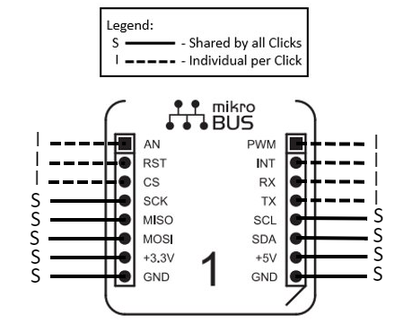

Figure 2: Pin Layout for mikroBus Standard Socket within PCB [1]

|  |  |
| --- | --- |
| **Acronym** | **Description** |
| AN | Analog |
| RST | Reset |
| CS | SPI Chip Select |
| SCK | SPI Clock |
| MISO | SPI Master Input Slave Output |
| MOSI | SPI Master Output Slave Input |
| PWM | PWM output |
| INT | Hardware Interrupt |
| RX | UART Receive |
| TX | UART Transmit |
| SCL | IIC Clock |
| SDA | IIC Data |
| GND | Reference Ground |

Table 1: Descriptions of Acronyms used in Figure 2

### Milestone #2

Milestone #2 is to write code, using the Mbed compiler, that will allow a total of 10 selected clicks to work interchangeably in the PCB from Milestone #1. To reiterate, the PCB will allow 4 Clicks to be connected at once but the code to make the Clicks compatible with the PCB will only be written for 10 selected Clicks due to time constraints. A total of 210 combinations will be possible. The proof can be seen in Equation 1 which uses the classic combinations formula allowing no repetitions and ignoring the order in which the Clicks are placed.

Number of Options = n

Number of Options Selected at one time = r

$$Total Combinations= \frac{n!}{r!*\left(n-r\right)!}=\frac{10!}{4!*\left(10-4\right)!}=210$$

Equation 1: Total Number of Combinations with Clicks and PCB

Milestone #3 will take place once the data can be successfully extracted from the Clicks to a computer using either a USB or Bluetooth signal. This milestone will focus on the creation of a website with an Analytics Display for the data gathered by the Clicks.

### Milestone #3

Milestone #3 will take place once the data can be successfully extracted from the Clicks to a computer using either a USB or Bluetooth signal. This milestone will focus on the creation of a website with an Analytics Display for the data gathered by the Clicks using Tableau, an analytics software. This part of the project mostly aims to demonstrate a real-world application and present a working platform for other users to expand on their own product. As such, it will be included links to all reference material necessary and give instructions on how to adapt the project to their own personal goals.

## Customer Requirements

Alfonso de la Morena:

From the customer’s perspective we aim to provide an open source platform that allows the use of multiple simultaneous Clicks on the FRDM-KL46Z. All the designs, source code and an instruction manual will be provided free of cost. Additionally, the project will be posted in the community forums of NXP, Mbed and MikroElektronika.

For Milestone #1, the design for the PCB is made such that it can be expanded on modularly with a different PCB. As can be observed in Figure 2, many of the pins are shared amongst the Clicks. The limitation for how many Clicks can be connected at once are set by the number of available pins and the power supply. From a customer’s perspective, if there was a desire to have a PCB that could hold 8 Clicks simultaneously, the customer could simply expand on the existing PCB design. Simply adding a multiplexer and making changes to the power supply would allow for more Clicks to be connected. However, this would be completely optional as the customer would also have the choice of simply using two of the 4 Click products to have 8 Clicks working simultaneously.

For Milestone #2, write code for the Mbed compiler that will allow a total of 10 selected clicks to work interchangeably in the PCB from Milestone #1, the code will be open source and available for download. This will allow the customer to adapt the readings collected from to the clicks to fit their own needs. It will also allow for the customer to use the software for the existing 10 Clicks as an example to write code for any other Click they wish to use.

For Milestone #3, the creation of the website and the software written for the selected Clicks are an example of a real-world application to prove the usefulness of the product, the customer will also have access to all the source code. This will allow the customer to see a working example of the data being passed on to an analytics software and then being displayed on a website. This platform will give a solid foundation for any projects the customer wishes to expand on.

## Existing System

Alfonso de la Morena:

There is no current system for what this product aims to accomplish. This project will solve the existing problem of not having a platform to interface between the FRDM-KL46Z and the Click sensors. Once completed, the project will allow for up to 4 simultaneous sensors to be connected to the FRDM-KL46Z at any time.

Although the design for this project could be modular, the system does run into some constraints when expanding to more than 4 Clicks simultaneously. One of those constraints is the power draw of each Click. This is discussed in section 2.8 of this document. The FRDM-KL46Z provides current for all the pins seen in Figure 2. This means that changing the number of Clicks that work simultaneously requires analyses of all the electrical power constraints. Additional there are also constraints when it comes to the number of pins available in the FRDM-KL46Z. The FRDM-KL46Z is only meant to handle 2 SPI, 1 IIC and 1 Analog interface at any point. The ability to operate 4 Clicks simultaneously is achieved by cycling from one to the next, either by using a MUX or sharing lines between all Clicks. If the design was expanded to include more Clicks, then there would need to be changes made to the PCB to accommodate those extra Clicks. [2]

## Terminology

Mohamed Sghari:

|  |  |
| --- | --- |
| **Term** | **Description** |
| FRDM-KL46Z | A microprocessor boards by NXP, it may be programmed using any of a large number of available tools. |
| Mbed | A platform and operating system for connecting devices and embedded devices based on 32-bit ARM Cortex-M microcontrollers. |
| Printed circuit Boards (PCB) | A printed circuit board that provide connections to electronic components using conductive tracks, pads and other features etched from sheet layers of copper. |
| Temp&Hum2 Click | A smart temperature and humidity sensor click board. It used Si7034 sensor that measures a wide range of temperature and relative humidity values with a great accuracy. |
| Weather Click | A sensor that detect humidity, pressure, and temperature. It carries BME280 integrated environmental unit. |
| Color 5 Click | A color sensor click board that detect red, green, and bleu components via I2C also detect infra-red spectrum via IR. It used P12347-01CT integrated color sensor. |
| BarGraph 2 Click | A 10-segment bar graph display click, which uses a high-quality, multicolor bar graph LED display.it provide a visual feedback like audio level, current/voltage level, position of the encoder etc. |
| Accel 5 Click | An ultra-low power triaxial accelerometer sensor, labeled as the BMA400. It allows linear motion and gravitational force measurements in ranges of ±2 g, ±4 g, ±8, and ±16 g in three perpendicular axes. |
| Gaussmeter Click | A sensor that measured the magnetic field in X, Y and Z axes. It carries a micropower magnetometer MLX90393. |
| LightRanger 3 Click | A sensor that measure distance using emitting Laser. It can measure a distance up to 2000mm with up to 10% accuracy. It carries RFD77402. |
| Alcohol Click | A sensor that is high sensitivity to alcohols. It carries MQ-3 sensor that detect alcohol concentration from 0.04 to 4mg/l. |
| Air Quality Click | A click that carries MQ-135 sensor for detection poisonous gases. |
| MicroSD Click | A click that provide the ability to add an addition memory via microSD cards. |
| MAX14830 | An advanced quad universal asynchronous receiver-transmitter. Each UART is having 128 words of receive and transmit first-in/first-out and a high-speed serial peripheral interface or controller interface. |
| SC16IS752 | A semiconductor ship that has a dual-channel high performance universal asynchronous receiver-transmitter.it offer data rate up to 5Mbit/s and provide application with 8 additional programmable I/O pins. |
| 33999 Ship | A semiconductor ship comes with 16-output low-side switch with SPI and PWM control. It interfaces with microcontrollers and it’s compatible with both 3.3 V and 5.0 V CMOS logic levels. |

# **Functional Description**

Mohamed Sghari:

Most of the functional applications of the Click Sensor Hub come from the Clicks themselves. The Clicks provide sensing capabilities that are sent to the FRDM-KL46Z so that it may process the data and later send it to a web display. A high level outline of this behavior can be seen in the figure below.

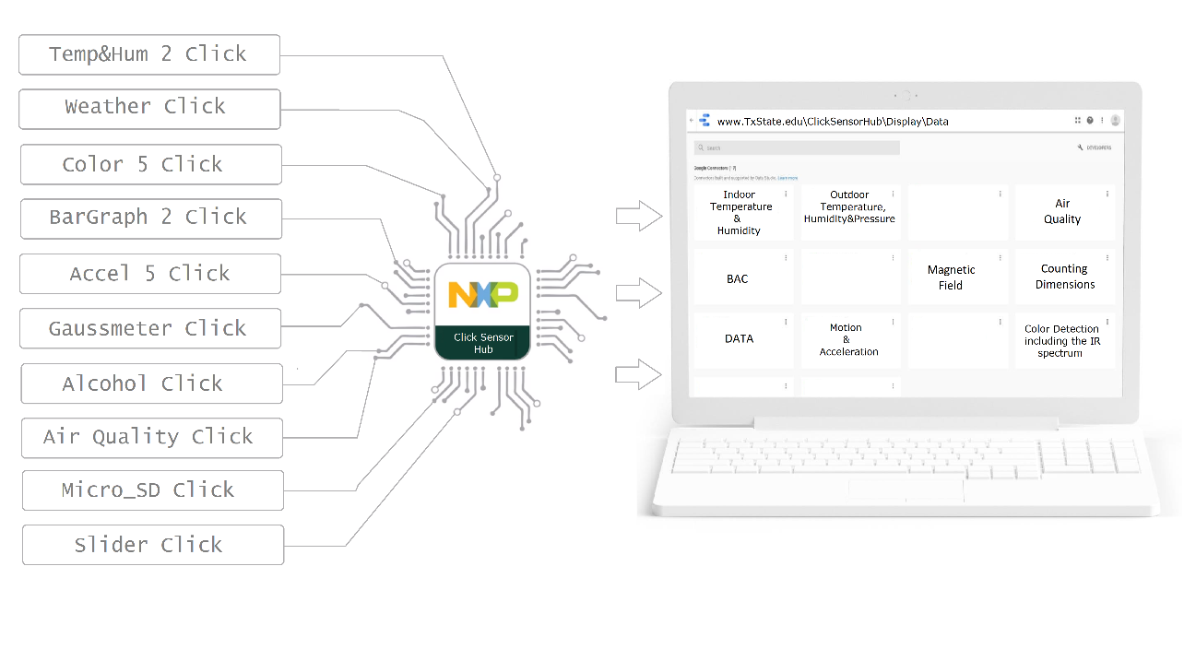

Figure 3: High Level Functional Diagram

The Clicks will perform a variety of functions. A general outline of these functions can be seen in the table below. Additionally, the table also specifies the price and interface connection of each Click.

|  |  |  |
| --- | --- | --- |
| **Features** | **Performance Targets** | **Price** |
| [Temp&Hum 2 Click](https://www.mikroe.com/temphum-2-click) | Measures a wide range of temperature and relative humidity values with a great accuracy   * 1.8 V Power supply * I2C interface | $16.00 |
| [Weather Click](https://www.mikroe.com/weather-click) | Detects humidity, pressure, and temperature   * 3.3V Power supply * SPI or I2C interface | $22.00 |
| [Color 5 click](https://www.mikroe.com/color-5-click) | Integrated color sensing device   * 3.3V and 5V Power supply * I2C interface | $16.00 |
| [BarGraph 2 Click](https://www.mikroe.com/bargraph-2-click) | 10-segment bar graph display click, which uses a high-quality, multicolor bar graph LED display   * 3.3V Power supply * PWM or SPI interface | $19.00 |
| [Accel 5 click](https://www.mikroe.com/accel-5-click) | Triaxial accelerometer sensor   * 3.3V Power supply * I2C or SPI interface | $19.00 |
| [Gaussmeter click](https://www.mikroe.com/gaussmeter-click) | Gaussmeter click is a device that is used for measuring the magnetic field in X, Y and Z axes   * 3.3V Power supply * I2C or SPI interface | $19.00 |
| [LightRanger 3 Click](https://www.mikroe.com/lightranger-3-click) | Accurate distance measurement based on a ToF (Time of Flight) measurement principle   * 3.3 V Power supply * I2C interface | $24.00 |
| [Alcohol Click](https://www.mikroe.com/alcohol-click) | Portable alcohol detector, breathalyzer for estimating BAC   * 3.3V Power supply * Analog interface | $15.00 |
| [Air Quality Click](https://www.mikroe.com/air-quality-click) | detecting a variety of gases that impact air quality in homes and offices   * 3.3V Power supply * Analog interface | $16.50 |
| [microSD click](https://www.mikroe.com/microsd-click?search_query=sd+card+click&results=6) | A microSD card slot for microSD cards used as a mass storage media for portable devices   * 3.3 V Power supply * SPI interface | $16.00 |

Table 2: Function, Interface and Price of each Click

## User Attributes and Use Cases

Alfonso de la Morena:

One of the key benefits of the Sensor Hub is its adaptability to the needs of the user. As such the general use case scenario can vary depending on the intended use of the product. The following entails the general steps needed to make use of the Sensor Hub.

|  |  |
| --- | --- |
| **Step 1** | Identify which Clicks are needed for your specific needs. |
| **Step 2** | Connect a maximum of 4 Clicks to the PCB and power the board. |
| **Step 3** | User the provided libraries to write code that detects data, following the constraints set by each Click, the FRDM-KL46Z and the PCB. |
| **Step 4** | Gather the data in FRDM-KL46Z and transmit it at a rate set by cable or wireless to your selected data base (not provided in the scope of this project). |
| **Step 5** | Analise, gather or display the data in a medium of your choice. |

The steps to use the product are intentional vague. The product, in its current state, is made for users with an existing level of engineering knowledge in the use of microprocessors. It is meant to work as a medium between users of the FRDM-KL46Z and Click sensors.

The following diagrams entail typical behaviour of the system when handling errors:

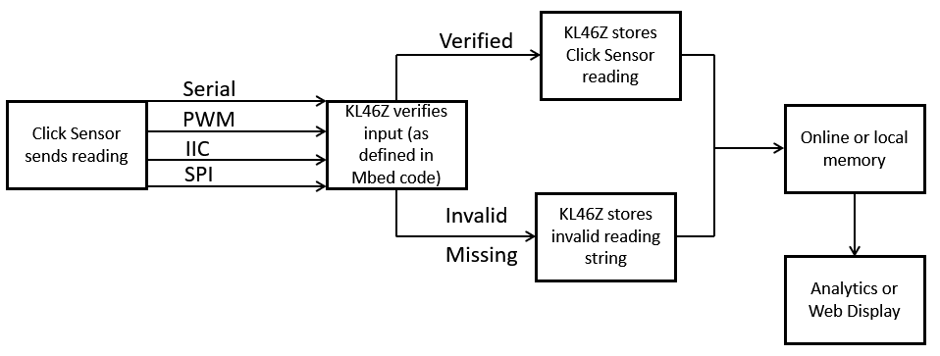

Figure 4: How System Handles Incorrect or Missing Readings from Click Sensors

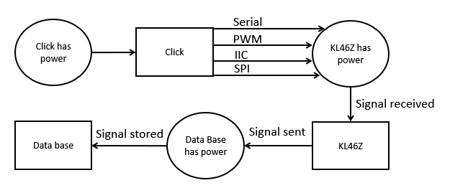

Figure 5: How System Handles Power Issues

As can be seen in Figure 5. The Click Sensor Hub is continuously storing its results in the data base. In the event of a loss of power at any of these points, the currently measured signal would fail to be stored. However, all signals before such an event should not be affected by the loss of power.

## Administration Functions

Dylan Dean:

N/A

*All users have access to FRDM-KL46Z system functions; no username or password is required. Users will also have access to any purchased Click system function; and open usage of the sensor hub. No user restrictions other than illegal device tampering laws which are

stipulated on an individual device basis by company legal disclaimers and appropriate government bureaus.

## Error Handling

Dylan Dean:

All electronic systems have a potential for errors. The greatest challenge is getting the modular docking system to properly interface with any selected clicks. This should be handled with both hardware and software. On the hardware side, chips that expand upon limited pin outs on the FRDM-KL46Z are going to be a must. On the software side, proper code parameters will need to be set to adapt accordingly to the given click function and operational voltage limit.

Some common cases to consider:

* Logical Error in the board caused by a signal delay, loss or overflow.
* Board Voltage exceeds maximum limit of 3.3V
* No Network Connection
* Battery Low
* Storage Media Not Found
* Storage Media Full
* Sensor Readings Out of Bounds

How to Handle common cases:

* Create a data signal Query, Create multiple data clone instances with a set time.
* Place a voltage limiter in the hardware, like a Zener Diode and software code a Max Voltage Flag condition for board protection.
* Reset Router or Use Global device reset.
* Use provided power cable or replace battery
* Display Error message ask user to input the SD card.
* Display Error message ask user to empty the SD card.
* Code a boundaries and parameters for every click that has been selected.

## Safety and Security

Dylan Dean:

Safety risks to consider:

* Voltages greater than 3.3Volts returned to the FRDM-KL46Z will causer fry the internal circuitry of the board.
  + Handled by placing a voltage limiter in the hardware, like a Zener Diode along with software code containing a max voltage flag condition both for user and board protection.
* Heat generated by the PCB should not harm the components or user.
  + To determine an acceptable operational temperature range, further research needs to be conducted. To handle the temperature safety a heatmap will be generated and appropriate electrical components will be added to reduce heat generation, heatsinks will also be added strategically around the board.

Security risks to consider:

* There are no significant security risks with the project because no personal information is being used and the device is an open IoT development kit. Also, for now the device is strictly for instructional purposes at Texas State University.
* The NXP Product Security Incident Response Team (PSIRT) responds to reported security vulnerabilities in NXP products. A link is provided detailing their security process. If there is a security issue with the FRDM-KL46Z refer to the following in the reference page of the document. [3]

## Help and User Documentation

Dylan Dean:

A User Guide for sensor hub will be provided, with the following instructions for students.

* How to download Mbed OS
* Quick reference guide for FRDM-KL46Z
* Quick reference guide for Click Sensor Hub
* Data Sheets for each Click
* How to get Bluetooth Connectivity
* How to access data from SD card
* Troubleshooting Errors
* Safety Warnings/Hazards
* Legal Disclaimers

Help and User Documentation required for the FRDM-KL46Z platform is handled by NXP. [4]

## Interfaces

### User

Dylan Dean:

Deferred to design specification stage. Unless requested after sponsor views first draft.

### Software

Dylan Dean:

Arm Mbed OS 5.10 or most recent compatible OS, will be used to program FRDM-KL46Z.

* Code will be implemented through a physical Micro USB connection

Website will be used to interact with data collected from clicks.

* Data can be sorted on the website and used to generate graphs and statistics.

### Hardware

Mohamed Sghari:

|  |  |  |  |  |  |  |
| --- | --- | --- | --- | --- | --- | --- |
| **Header** | **KL46 Ports** | **Arduino compatibility** | **Pin #** | **Pin #** | **KL46 Ports** | **Arduino compatibility** |
|  | PTA1 | D0/RX/int | 2 | 1 | PTB18 | I2S_TX_BCLK |
|  | PTA2 | D1/TX/int | 4 | 3 | PTB19 | I2S_TX_FS |
|  | PTD3 | D2/int | 6 | 5 | PTC0 | I2S_TXD |
|  | PTA12 | D3/PWM/int | 8 | 7 | PTC4 | I2S_MCLK |
| **J1** | PTA4 | D4/int | 10 | 9 | PTC6 | I2S_RX_BCLK |
|  | PTA5 | D5/PWM/int | 12 | 11 | PTC7 | SOF_OUT |
|  | PTC8 | D6/PWM/CMP/int | 14 | 13 | PTC10 | I2S_RX_FS |
|  | PTC9 | D7/CMP/int | 16 | 15 | PTC11 | I2S_RXD |
|  | PTA13 | D8/Input Capture/int | 2 | 1 | PTC13 |  |
|  | PTD2 | D9/PWM/int | 4 | 3 | PTC16 |  |
|  | PTD4 | D10/SPI_SS/PWM/int | 6 | 5 | PTA7 |  |
|  | PTD6 | D11/MOSI/int | 8 | 7 | PTA6 |  |
| **J2** | PTD7 | D12/MISO/int | 10 | 9 | PTA14 |  |
|  | PTD5 | D13/SCK/LED/int | 12 | 11 | PTA15 |  |
|  | ------------ | GND | 14 | 13 | PTA16 |  |
|  | ------------ | AREF | 16 | 15 | PTA17 |  |
|  | PTE0 | D14/SDA/Ana | 18 | 17 | PTB9 |  |
|  | PTE1 | D15/SCL/Ana | 20 | 19 |  |  |
|  | P5-9V | P5-9V | 16 | 15 | PTE2 |  |
|  | GND | GND | 14 | 13 | PTE3 |  |
|  | GND | GND | 12 | 11 | PTE6 |  |
|  | P5V_USB | P5V_USB | 10 | 9 | PTE16 |  |
| **J3** | P3V3 | P3V3 | 8 | 7 | PTE17 |  |
|  | RST | RESET_TGTMCU | 6 | 5 | PTE18 |  |
|  | P3V3 | P3V3 | 4 | 3 | PTE19 |  |
|  | SDA-PTD5 | SDA-PTD5 | 2 | 1 | PTE31 |  |
|  | PTC1 | A5/SCL/int | 12 | 11 | PTE30 | DAC_OUT |
|  | PTC2 | A4/SDA/int | 10 | 9 | PTB20 | CMP_OUT |
| **J4** | PTB3 | A3 | 8 | 7 | PTE23 | DIFF_ADC1_DM |
|  | PTB2 | A2 | 6 | 5 | PTE22 | DIFF_ADC1_DP |
|  | PTB1 | A1 | 4 | 3 | PTE21 | DIFF_ADC0_DM |
|  | PTB0 | A0 | 2 | 1 | PTE20 | DIFF_ADC0_DP |

Table 3: FRDM-KL46Z Pin Assignment [4]

|  |  |  |  |
| --- | --- | --- | --- |
| **Number of Pin** | **Port name** | **Number of Pin** | **Port name** |
| 2 | USB | 6 | PWM *Pulse Width Modulation* |
| 2 | SPI *Serial Peripheral Interface* | 6 | ADC *Analog-to-Digital* |
| 2 | I2C *Inter-Integrated Circuit* | 1 | DAC 6-Bit *Digital to Analog* |
| 1 | I2S *Inter-IC Sound* | 1 | DAC 12Bit *Digital to Analog* |
| 3 | UART *Universal Asynchronous receiver-transmitter* | 84 | GPIO *General Purpose Input/Output* |

Table 4: FRDM-KL46Z Port Availability [4]

|  |  |  |  |
| --- | --- | --- | --- |
| **PIN function** | **PIN iD** | **PIN iD** | **PIN Function** |
| Analog | AN | PWM | PWN output |
| Reset | EST | INT | Hardware Interrupt |
| SPI chip Select | CS | RX | UART Receive |
| SPI Clock | SCK | TX | UART Transmit |
| SPI  Master input  Slave output | MISO | SCL | I2C clock |
| SPI  Master output  Slave input | MOSI | SDA | I2c data |
| VCC – 3.3V Power | +3.3V | +5V | VCC – 5V Power |
| Reference Ground | GND | GND | Reference Ground |

Table 5: Click Mikro BUS’PIN Layout [4]

|  |  |
| --- | --- |
| **Pin Groups** | **PIN Names** |
| Communication Pins | SPI, UART, I2C |
| Additional Pins | PWM, Interrupt, Analog input, Reset, Chip Select |
| Power Pins | +3.3V, +5V |

Table 6: General information about Click Mikro Bus Ports [1]

|  |  |
| --- | --- |
| **Click Connection** | **Connection Type** |
| GND | Shared |
| 3.3V 5V | Shared |
| SPI: SCK  SPI: MOSI  SPI: MISO | Shared |
| I2C SCL  I2C SDA | Shared |
| Analog | Unique |
| PWM | Unique |
| SPI: CS | Unique |
| INT | Unique |
| RS232 (TX, RX) | Unique per clock |

Table 7: Shared and Unique Pins in PCB Design

### Mechanical

Dylan Dean:

* A global reset button used in the FRDM-KL46Z
* A local reset button used on the FRDM-CSH
* Designed device housing, to keep the boards safe from moisture and dust when not in operation.

## Boundary Conditions and Constraints

Alfonso de la Morena:

The project has well defined minimum requirements that allow the Click Sensor Hub to be considered a success. The following in the table below outlines the general scope conditions that need to be met in order to complete the project.

|  |  |  |
| --- | --- | --- |
| **Condition** | **Minimum Accepted** | **Maximum Accepted** |
| FRDM-KL46Z needed for operation of system | 1 | 1 |
| Click Sensor Hub PCB needed for operation of system | 1 | 1 |
| Click Sensors needed to transmit sensor readings from a selection of 10 available | 1/10 | 4/10 |
| Code written in Mbed for selected Clicks | 10 | 10 |
| Website with analytics to display the collected data | 1 | 1 |
| Project Budget | 0$ | 500$ |

Table 8: General Project Scope Conditions and Boundaries

Each of the Clicks selected for this project will have boundary condition according to the measurement they are taking. A list for reference of all boundary conditions of the 10 Clicks selected to be in the scope of this project can be seen in the table below.

|  |  |  |  |  |
| --- | --- | --- | --- | --- |
| **Click** | **Sensor Name** | **Description** | **Reference** | **Company** |
| [Temp&Hum 2 Click](https://www.mikroe.com/temphum-2-click) | Si7034 | Digital I2c Humidity and Temperature Sensor | [5] | Silicon Labs |
| [Weather Click](https://www.mikroe.com/weather-click) | BME280 | Combined humidity and pressure sensor | [6] | BOSCH |
| [Color 5 click](https://www.mikroe.com/color-5-click) | P12347 | Color/proximity sensor | [7] | Hamamatsu |
| [BarGraph 2 Click](https://www.mikroe.com/bargraph-2-click) | SN74HC595 | 8-Bit Shift Registers With 3-State Output Registers | [8] | Texas Instruments |
| [Accel 5 click](https://www.mikroe.com/accel-5-click) | BMA400 | Ultra-low power, triaxial accelerometer | [9] | BOSCH |
| [Gaussmeter click](https://www.mikroe.com/gaussmeter-click) | MLX90393 | Micropower Triaxis® Magnetometer | [10] | Melexis |
| [LightRanger 3 Click](https://www.mikroe.com/lightranger-3-click) | RFD77402 | Simblee IoT 3D ToF Sensor Module | [11] | RF Digital |
| [Alcohol Click](https://www.mikroe.com/alcohol-click) | MQ-3 | Semiconductor Sensor for Alcohol | [12] | N/A |
| [Air Quality Click](https://www.mikroe.com/air-quality-click) | MQ-135 | Air quality control equipment | [13] | N/A |
| [microSD click](https://www.mikroe.com/microsd-click?search_query=sd+card+click&results=6) | SD | Micro SD card slot | [14] | SanDisk |

Table 9: Sensor Reference Table for Clicks

## Performance

Alfonso de la Morena:

It is within the scope of the project to test the interaction between already existing components. Therefore, many of the parts used in the Click Sensor Hub, such as the FRDM-KL46Z and the Clicks, have all been thoroughly tested by the companies responsible for those products. The scope of testing in this project will aim to prove the products work as intended by their respective manufactures when communicating with each other.

|  |  |  |  |  |  |
| --- | --- | --- | --- | --- | --- |
| ***Hardware Performance Parameters*** | | | | | |
| ***Parameter*** | ***Test Conditions*** | ***Min*** | ***Max*** | ***Units*** | ***How Tested*** |
| *Power Supply Voltage of PCB* | *PCB has been on for at least 1 minute* | *3.2* | *3.4* | *Volts* | *Board will transmit data to database while powered by a voltage supply within the accepted range* |
| *PCB board temperature* | *PCB has been on for at least 1 minute* | *20* *°* | *150°* | *Celsius* | *Board will be tested with a temperature sensor to detect temperatures outside the range* |
| *Click Sockets work for any Click* | *PCB is on* | *2* | *3* | *Clicks* | *Each socket in PCB will be tested with at least 2 Clicks. The connection must be recognized by the FRDM-KL46Z which must receive a sensor reading.* |
| *Click sensor functionality* | *Each Click is powered on and placed on a breadboard* | *10* | *10* | *Click* | *Each Click will be tested for output on a breadboard before being connected to the main board. It must send a signal according to the type of interface it uses.* |
| *FRDM-KL46Z Functionality* | *FRDM-KL46Z is on and placed on a breadboard.* | *20* | *30* | *Pins* | *The pins on the FRDM-KL46Z will be tested with an Mbed program that will turn on a flag each time a pin receives a signal.* |

|  |  |  |
| --- | --- | --- |
| ***Software Performance Parameters*** | | |
| ***Function*** | ***Description*** | ***How Tested*** |
| *New releases* | *When a new/updated version or release of the software is released, the website will post an update should be notified.* | *Include latest version tab in website and update it with a fake version* |
| *Website loading times* | *Loads in 30 seconds or less* | *Use a timer to measure load time* |
| *Memory usage* | *The amount of Operating System memory occupied by the application. Target is 1GB, limit is 10GB.* | *Observations done from the performance log during testing.* |
| *System reliability* | *The reliability that the system gives the right result.* | *Feed 20 different data streams to website during testing.* |
| *Website easy to use* | *Intuitive interface and clear data display.* | *Each member of the team will show website to 2 other users and record their opinions and suggestions on the design.* |
| *Platforms* | *The system will run on the following computer platforms: (a) Windows 10 (b) Windows 7* | *Test all functions listed above on all platforms* |

## Software Platforms

Dylan Dean:

* FRDM-KL46Z
* ARM Mbed OS 5.10
* Website host using GitHub

## Service, Support, & Maintenance

Dylan Dean:

* Maintenance #1 required to keep the board and docking station clean of dust and clear of moisture.
* Maintenance #2 Make sure to keep Mbed OS up to date on most stable version.
* Maintenance #3 If not using provided cable connection for power supply, maintain a charged nine-volt battery.

## Expandability or Customization

Dylan Dean:

* Four Clicks Docked expanded to Ten Clicks Docked.
* Docking Station can be customized into different Click layouts. For this project there are a potential of two hundred and ten combinations.
* Expand the boards modular capabilities with more coding to handle an even wider variety of clicks beyond the ten selected for the scope of current project.
* Add Bobcat Logo to the Docking station.
* Possibly go beyond classroom usage and have NXP sell as an expansion product for the FRDM-KL46Z platform.

# **Project Alignment Matrix**

Alfonso de la Morena:

Outside Advisors (if any) and affiliations: N/A

**TABLE 1: Knowledge Alignment Matrix**

|  |  |  |
| --- | --- | --- |
| **Course No.** | **Core knowledge** | **Specific knowledge incorporated by team** |
| EE 3350 (Electronics I) | Design and analysis of active devices and equivalent circuits | Knowledge to analyse power consumption and max current in PCB. |
| EE 3370 (Signals and Systems) | Frequency domain representation of signals and frequency response, transfer functions | N/A |
| EE 3420 (Microprocessors) | Principles of operation and applications of microprocessors | Creating PCB that interfaces between FRDM-KL46Z and 4 simultaneous Clicks |
| EE 4352 (Introduction to VLSI Design) | Analysis and design of CMOS integrated circuits | N/A |
| EE 4370 (Communications Systems) | Transmission of signals through linear systems, analog and digital modulation, and noise | Communication between the FRDM-KL46Z and a host pc that will use the transmitted data. |

**TABLE 2: Constraint Alignment Matrix (and applicable standards)**

ABET Criterion 3 (c): “an ability to design a system, component, or process to meet desired needs within realistic constraints such as economic, environmental, social, political, ethical, health and safety, manufacturability, and sustainability.”

|  |  |
| --- | --- |
| **Constraint Type** | **Specific Project Constraint** |
| Economic | Our 500$ budget restrained the design to 10 total Clicks to work on |
| Environmental | The energy consumption of the design must be minimized when possible |
| Health and safety | Miscalculations in power constraints could cause fire or shock hazards |
| Social/Ethical | A system with access to so many sensors could be used to invade on people’s privacy |
| Applicable Standards | IEEE Code of Ethics Section 7.8.5 |

# **References**

|  |  |
| --- | --- |
| [1] | mikroElektronika, "mikrobus-standard-specification-v200," [Online]. Available: https://download.mikroe.com/documents/standards/mikrobus/mikrobus-standard-specification-v200.pdf. [Accessed October 2018]. |
| [2] | NXP, "FRDM-KL46Z: Freedom Development Platform for Kinetis® KL3x and KL4x MCUs," NXP, [Online]. Available: https://www.nxp.com/support/developer-resources/evaluation-and-development-boards/freedom-development-boards/mcu-boards/freedom-development-platform-for-kinetis-kl3x-and-kl4x-mcus:FRDM-KL46Z. [Accessed October 2018]. |
| [3] | NXP, "Report Product Security Vulnerabilities," NXP, [Online]. Available: https://www.nxp.com/support/support/report-product-security-vulnerabilities:PSIRT. [Accessed October 2018]. |
| [4] | NXP, "FRDM-KL46Z," [Online]. Available: https://www.nxp.com/downloads/en/schematics/FRDM-KL46Z_SCH.pdf. [Accessed October 2018]. |
| [5] | Silicon Labs, "Digital I2c Humidity And Temperature Sensor," 2015. [Online]. Available: https://download.mikroe.com/documents/datasheets/Si7034.pdf. |
| [6] | BOSCH, "Final Data Sheet - BME280 - Combined humidity and pressure sensor," 26 October 2015. [Online]. Available: https://download.mikroe.com/documents/datasheets/BST-BME280_DS001-11.pdf. |
| [7] | Hamamatsu, "P12347 - Color/proximity sensor," August 2017. [Online]. Available: https://download.mikroe.com/documents/datasheets/p12347-01ct_kpic1084e.pdf. |
| [8] | Texas Instruments, "SN74HC595 - 8-Bit Shift Registers With 3-State Output Registers," September 2015. [Online]. Available: https://download.mikroe.com/documents/datasheets/sn74hc595-datasheet.pdf. |
| [9] | BOSCH, "BMA400 - Ultra-low power, triaxial accelerometer," 2017. [Online]. Available: https://download.mikroe.com/documents/datasheets/BMA400.pdf. |
| [10] | Melexis, "MLX90393 - Micropower Triaxis® Magnetometer," February 2015. [Online]. Available: https://download.mikroe.com/documents/datasheets/MLX90393%20Datasheet.pdf. |
| [11] | RF Digital, "RFD77402 - Simblee IoT 3D ToF Sensor Module," 2017. [Online]. Available: https://download.mikroe.com/documents/datasheets/RFD77402%20Datasheet.pdf. |
| [12] | mikroElektronika, "MQ-3 - Semiconductor Sensor for Alcohol," [Online]. Available: https://download.mikroe.com/documents/datasheets/mq3-alcohol-sensor-datasheet.pdf. |
| [13] | mikroElektronika, "MQ-135 Gas Sensor," [Online]. Available: https://www.olimex.com/Products/Components/Sensors/SNS-MQ135/resources/SNS-MQ135.pdf. |
| [14] | SanDisk, "SanDisk microSD," March 2010. [Online]. Available: https://www.alliedelec.com/m/d/04db416b291011446889dbd6129e2644.pdf. |

# **Approvals**

The signatures of the people below indicate an understanding in the purpose and content of this document by those signing it. By signing this document, you indicate that you approve of the proposed project outlined in this Functional Specification and that the next steps may be taken to proceed with the project.

|  |  |  |  |
| --- | --- | --- | --- |
| **Approver Name** | **Title** | **Signature** | **Date** |
| Alfonso de la Morena | Project Manager |  |  |
| Vanessa Yanez | D2 Project Manager |  |  |
| Dr. Stapleton | Faculty Sponsor |  |  |
| Dr. Kemp | Sponsor |  |  |
| Dr. Hinkle | Instructor |  |  |